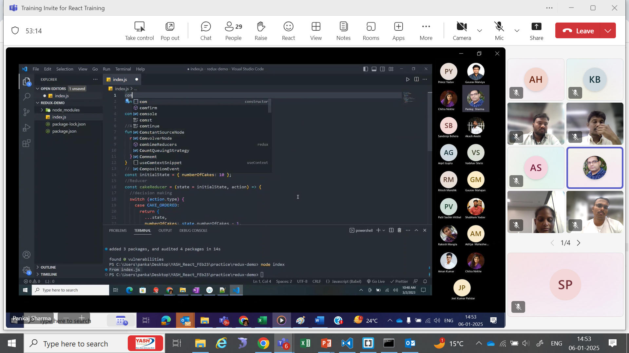

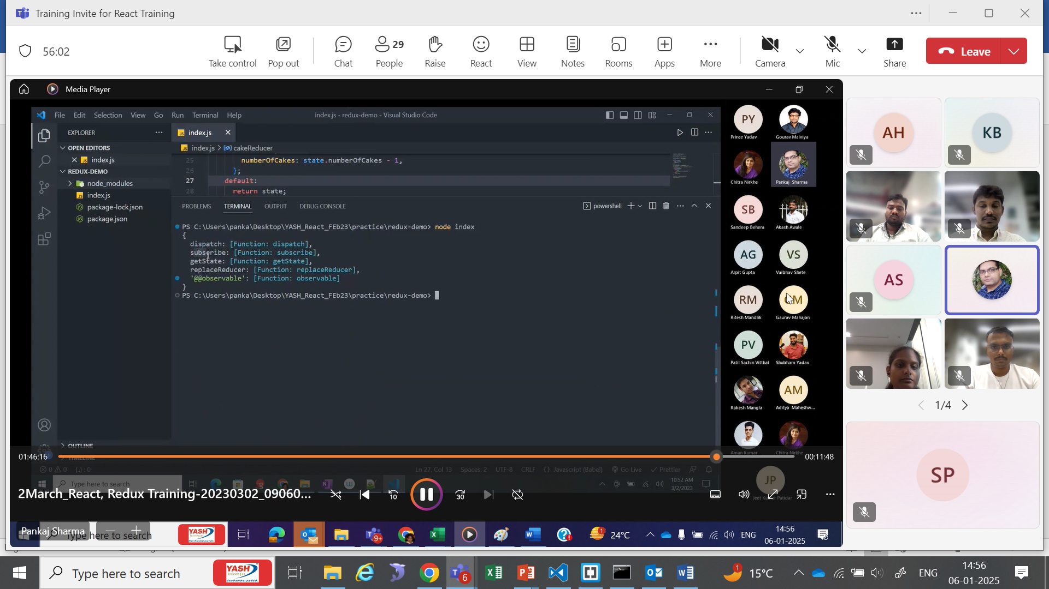

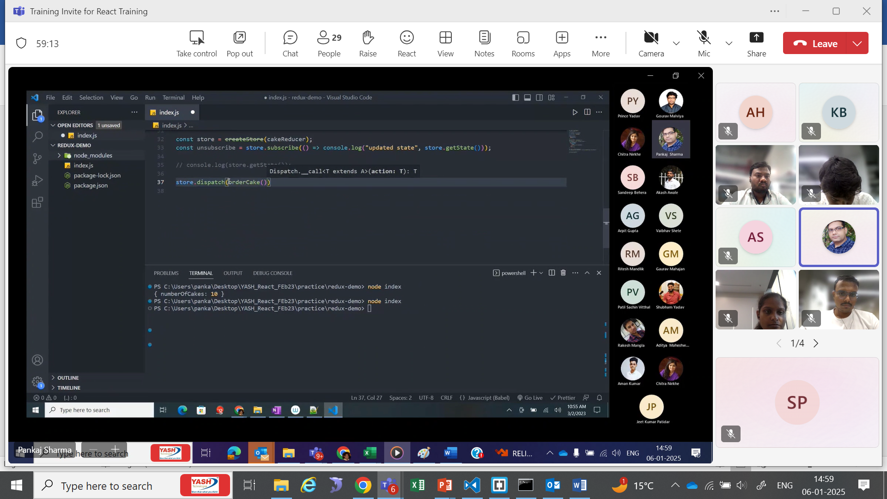

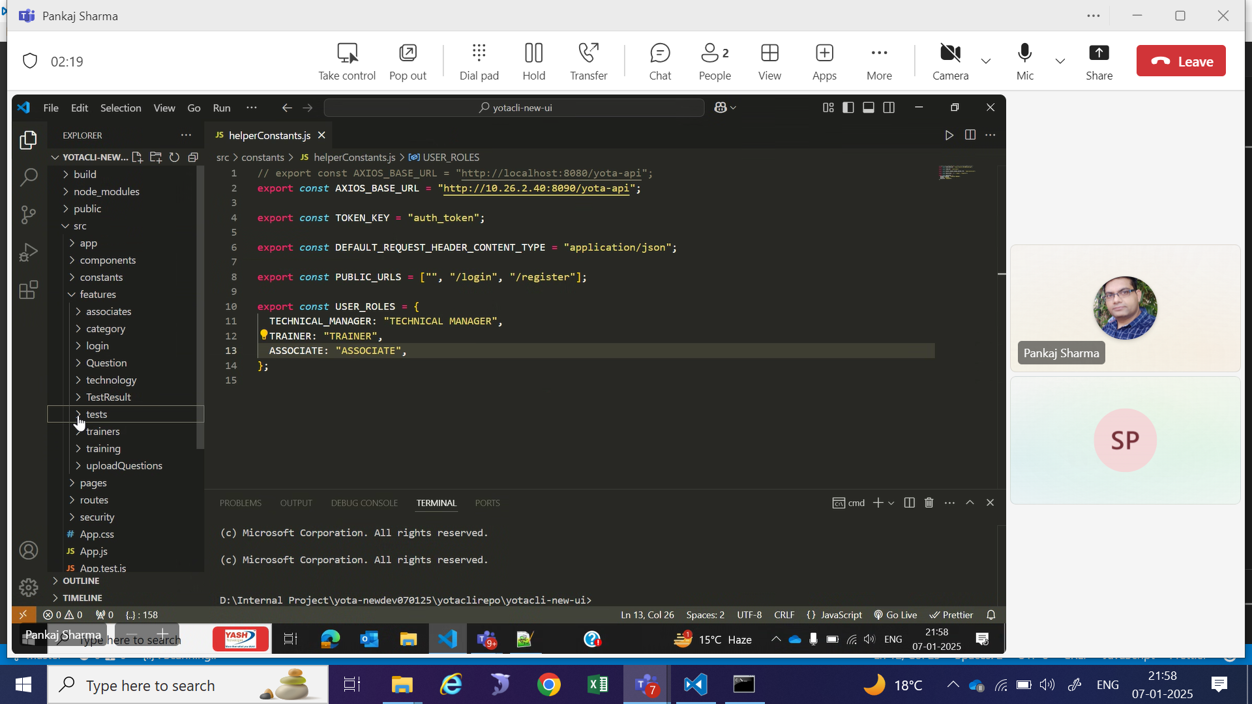

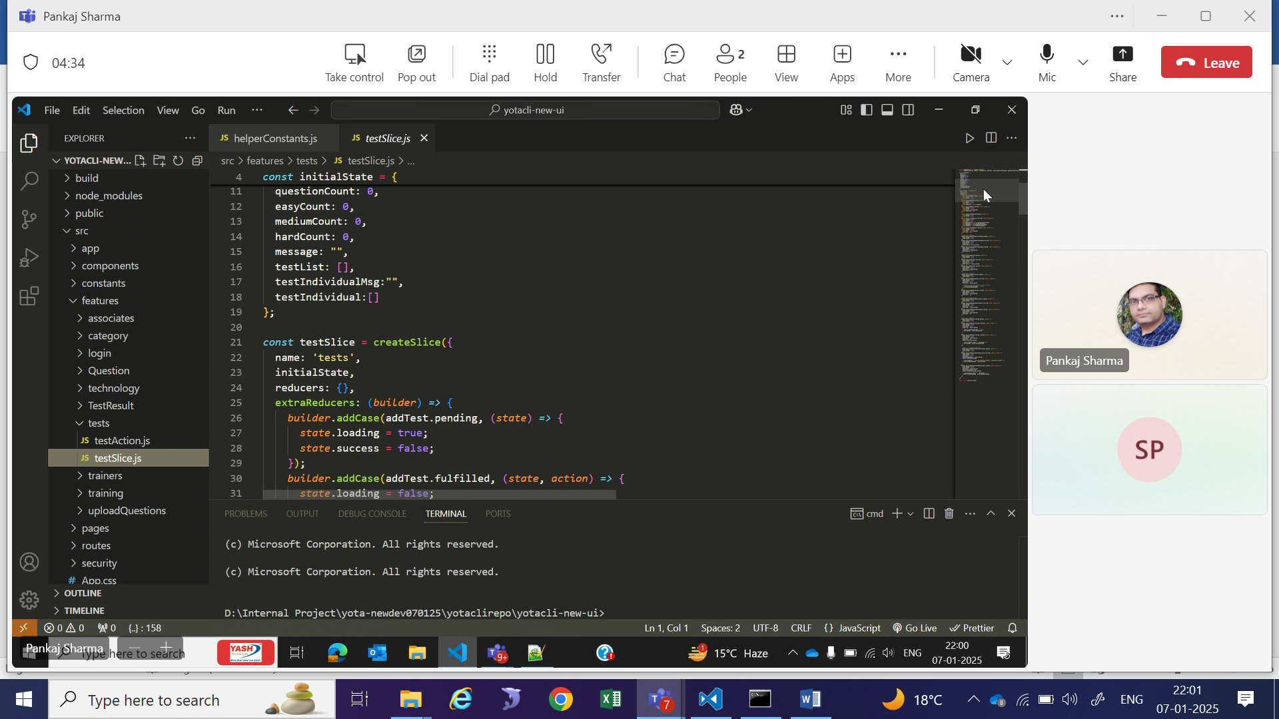

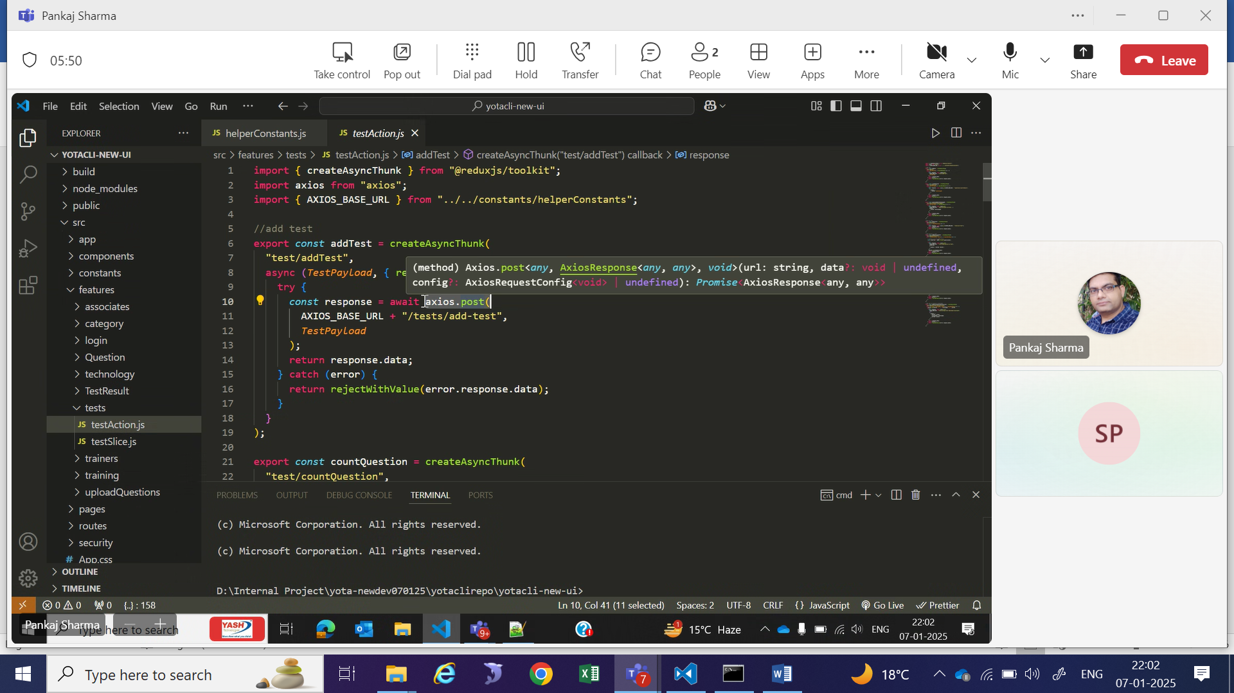

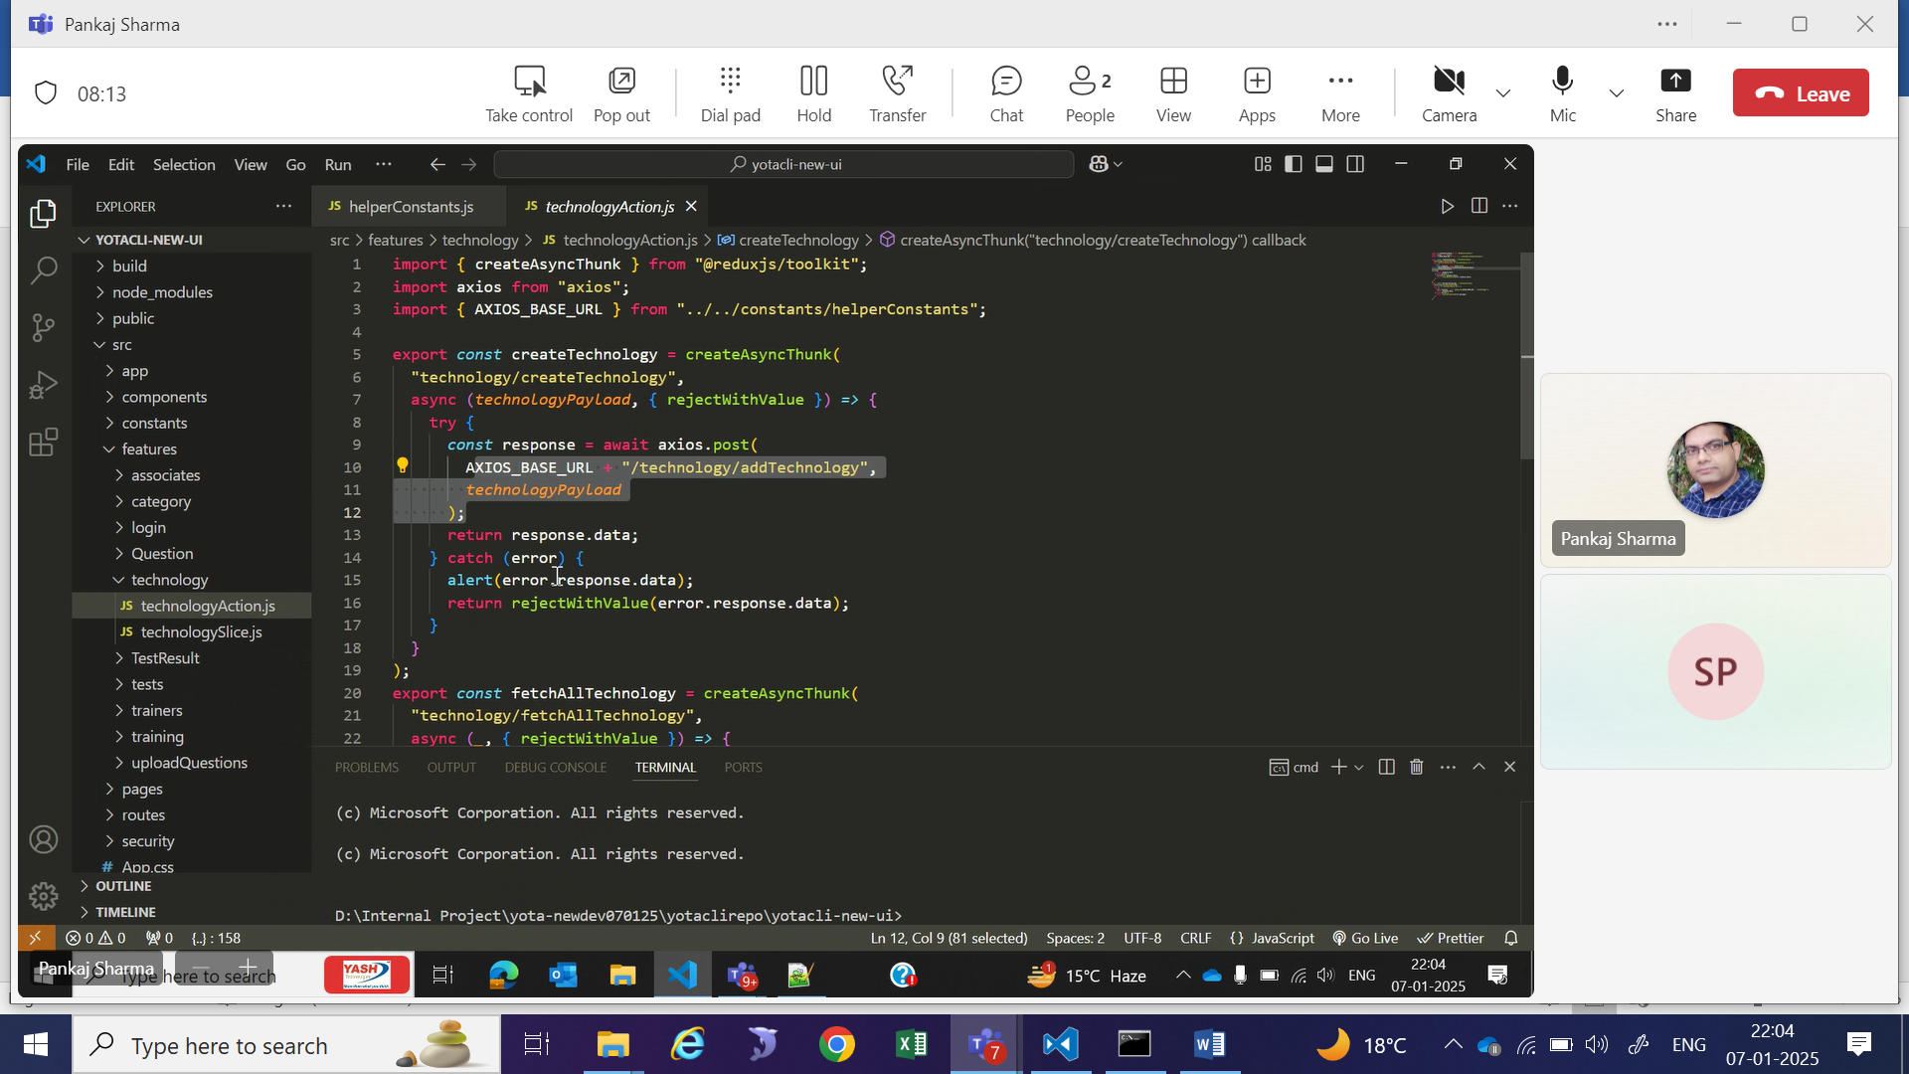

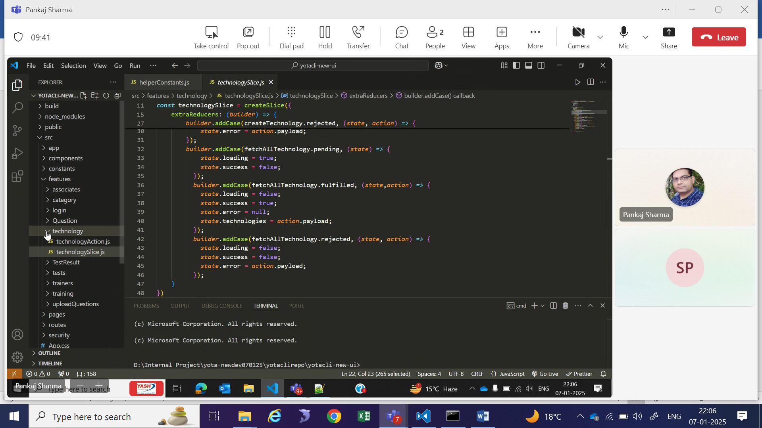

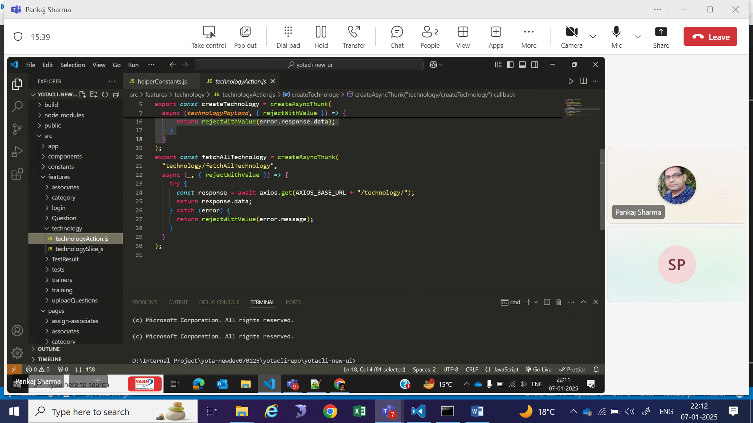

**What is React.js?**

**React.js** is a popular open-source JavaScript library developed by **Facebook** for building user interfaces, especially for single-page applications. It focuses on creating reusable UI components and is known for its efficiency, flexibility, and declarative nature.

**Key Features of React.js**

1. **Component-Based Architecture**:
   * React applications are built using small, reusable components.
   * Each component can manage its own state and logic, making the app modular and easier to maintain.
2. **Declarative**:
   * React uses a declarative approach to describe the UI, meaning you specify **what you want** the UI to look like, and React handles the rendering efficiently.
3. **Virtual DOM**:
   * React uses a **Virtual DOM** to improve performance. Instead of updating the actual DOM directly, React creates a virtual representation of the DOM and updates only the parts of the UI that have changed.
4. **JSX (JavaScript XML)**:
   * React uses JSX, a syntax extension that looks like HTML but is written inside JavaScript. It makes the code more readable and easier to write.
5. **Unidirectional Data Flow**:
   * React uses a one-way data-binding approach, meaning data flows in a single direction, which simplifies debugging and ensures predictable application behavior.
6. **State and Props**:
   * **State**: Used to manage data within a component.
   * **Props**: Short for "properties," props allow data to be passed between components.
7. **Ecosystem and Tools**:
   * React has a rich ecosystem, including tools like React Router for navigation and Redux or Context API for state management.
8. **Cross-Platform Development**:
   * React can be used to develop web applications, and with **React Native**, it can also build mobile applications for iOS and Android.

**Why Use React.js?**

1. **Fast and Efficient**:
   * React’s Virtual DOM minimizes direct interaction with the real DOM, leading to faster updates and rendering.
2. **Reusable Components**:
   * Write once, reuse everywhere. Components make development faster and more consistent.
3. **Large Community and Ecosystem**:
   * React has a huge developer community, extensive documentation, and a wide array of third-party libraries and tools.
4. **Easy to Learn**:
   * React focuses on JavaScript and basic UI concepts, making it easier for developers familiar with JavaScript to pick up.
5. **Strong Backing**:
   * React is maintained by **Meta** (formerly Facebook) and has been used in large-scale applications like Facebook, Instagram, and WhatsApp.

**How React Works**

1. **Step 1: Create Components**  
   Developers create components using JSX and JavaScript. These components define what should be displayed in the UI.
2. **Step 2: Virtual DOM**  
   React creates a lightweight copy of the real DOM in memory, called the Virtual DOM.
3. **Step 3: Reconciliation**  
   When there is a change in the application’s state, React compares the new Virtual DOM with the previous one (using a process called **diffing**) to find the differences.
4. **Step 4: DOM Update**  
   Only the parts of the real DOM that changed are updated, ensuring better performance.

**What is an SPA (Single-Page Application)?**

A **Single-Page Application (SPA)** is a type of web application that dynamically updates and renders content on a single HTML page. Instead of loading entire new pages from the server for every user interaction, SPAs fetch data and update the content dynamically using JavaScript, resulting in a faster and more seamless user experience.

**Key Characteristics of SPAs**

1. **Single HTML File**:
   * SPAs typically use a single index.html file, and the content updates dynamically based on user actions.
2. **Dynamic Content Loading**:
   * Content and data are loaded using JavaScript (often through APIs or AJAX calls), avoiding full page reloads.
3. **Routing Without Reloads**:
   * SPAs manage navigation using client-side routing, ensuring that the URL changes while the page remains loaded.
4. **Enhanced User Experience**:
   * Faster interactions, as only the required data is fetched and rendered.
5. **Client-Side Rendering (CSR)**:
   * SPAs rely heavily on JavaScript to render components and update the DOM directly in the browser.

**How SPAs Work**

1. **Initial Page Load**:
   * The browser loads a single HTML file, along with the necessary JavaScript and CSS files.
2. **Dynamic Updates**:
   * User actions trigger JavaScript functions, which fetch data from the server (via APIs) and update the page dynamically.
3. **Client-Side Routing**:
   * When users navigate to a different "page," the application changes the URL and renders the new content without reloading the HTML file.

**Advantages of SPAs**

1. **Faster Performance**:
   * Only the necessary data is loaded instead of the entire page, reducing load times after the initial request.
2. **Smooth User Experience**:
   * No page refreshes mean seamless transitions between views.
3. **Reduced Server Load**:
   * The server only sends data (usually JSON), rather than full HTML pages, reducing overhead.
4. **Better for Mobile and Progressive Web Apps (PWAs)**:
   * SPAs are lightweight and ideal for creating responsive, app-like web experiences.
5. **Reusability**:
   * Components and logic can be reused across different parts of the application.

**Disadvantages of SPAs**

1. **Initial Load Time**:
   * The initial page load can be slower because JavaScript and assets need to be downloaded upfront.
2. **SEO Challenges**:
   * Since content is rendered on the client side, search engines might have difficulty indexing SPAs. (Solutions like server-side rendering or prerendering address this.)
3. **JavaScript Dependency**:
   * SPAs rely heavily on JavaScript; if it's disabled in a browser, the app may not function.
4. **Complex State Management**:
   * As SPAs grow, managing state across components can become challenging, requiring tools like Redux or React Context.

**Examples of SPAs**

1. **Popular SPAs**:
   * Gmail
   * Google Maps
   * Facebook
   * Twitter
   * Netflix
2. **Frameworks for Building SPAs**:
   * React.js
   * Angular
   * Vue.js

### ****What is a React Component?****

A **React Component** is a self-contained, reusable piece of code that defines a part of the user interface (UI) in a React application. It can be thought of as a **building block** of a React application.

#### **Types of React Components**

1. **Function Components**:
   * These are simple JavaScript functions that return JSX (React's syntax for defining UI).

jsx

Copy code

function Welcome() {

return <h1>Hello, World!</h1>;

}

1. **Class Components** (older approach, less common now):
   * These are ES6 classes that extend React.Component and must have a render() method.

jsx

Copy code

class Welcome extends React.Component {

render() {

return <h1>Hello, World!</h1>;

}

}

#### **Why Are React Components Important?**

1. **Reusability**: Components can be reused across different parts of the application, reducing duplication and improving maintainability.
2. **Separation of Concerns**: Each component handles one specific part of the UI, making it easier to manage and debug.
3. **Composition**: Components can be combined to create complex UIs.
4. **State and Logic**: Components can manage their own state and contain specific logic, making them modular and independent.

### ****2. Why is React Called a Declarative Library?****

React is called **declarative** because developers describe **what the UI should look like**, and React efficiently manages the rendering and updating of the DOM to achieve that desired state.

#### **Declarative vs Imperative**

* **Declarative**: Focuses on **what to do**. You describe the final outcome, and React takes care of how to achieve it.

const App = () => <h1>Hello, World!</h1>;

* **Imperative**: Focuses on **how to do it**, requiring step-by-step instructions to manipulate the DOM.

const element = document.createElement('h1');

element.innerText = 'Hello, World!';

document.body.appendChild(element);

### ****3. How to Bootstrap a React Project in the Latest Version****

#### **Using Create React App (CRA)** (Recommended for beginners)

1. Open your terminal and run:

npx create-react-app my-app

1. Navigate into the project folder:

cd my-app

1. Start the development server:

npm start

#### **Using Vite (Faster alternative)**

1. Install Vite with React template:

npm create vite@latest my-app --template react

1. Navigate into the project folder:

cd my-app

1. Install dependencies:

npm install

1. Start the development server:

npm run dev

### ****4. Understanding React Project Structure****

When you create a React project, the folder structure typically looks like this:

java

Copy code

my-app/

├── node_modules/ // Project dependencies

├── public/ // Static assets (e.g., index.html, favicon)

├── src/ // Main source code

│ ├── App.css // Styling for App component

│ ├── App.js // Main application component

│ ├── index.js // Entry point of the app

│ ├── components/ // Folder for reusable components

│ ├── pages/ // Folder for different pages (optional)

├── package.json // Project configuration

└── README.md // Project documentation

### ****5. How to Start a React Project****

1. Ensure you have Node.js and npm installed (use node -v and npm -v to check).
2. Bootstrap a new project using CRA or Vite (instructions above).
3. Run npm start (CRA) or npm run dev (Vite) to start the development server.
4. Open your browser and go to http://localhost:3000 to see your app.

### ****6. Basics of JSX****

**JSX** stands for **JavaScript XML**. It is a syntax extension that looks like HTML but is used in React to define the UI.

#### **Key Features of JSX**

1. **HTML-like Syntax**:

jsx

Copy code

const element = <h1>Hello, JSX!</h1>;

1. **Embedding Expressions**: You can embed JavaScript expressions in JSX using curly braces {}:

jsx

Copy code

const name = "John";

const greeting = <h1>Hello, {name}!</h1>;

1. **Using Components**: Components can be rendered using JSX tags:

jsx

Copy code

function Welcome() {

return <h1>Welcome!</h1>;

}

const app = <Welcome />;

1. **Attributes in JSX**: Use camelCase for attributes:

const button = <button onClick={handleClick}>Click Me</button>;

### ****7. How Does React Work?****

React’s operation is centered around the **Virtual DOM** and its ability to efficiently update the real DOM.

#### **Step-by-Step Workflow**

1. **Write Components**: You define components using JSX and JavaScript.
2. **Virtual DOM**: React creates a lightweight in-memory representation of the real DOM, called the **Virtual DOM**.
3. **Reconciliation**: When the state or props change, React compares the new Virtual DOM with the previous version (a process called **diffing**) to identify what changed.
4. **Efficient DOM Updates**: React updates only the parts of the real DOM that have changed, improving performance.
5. **Rendering**: React renders the updated UI to the browser.

### ****Example Workflow****

1. **Component Definition**:

function App() {

const [count, setCount] = React.useState(0);

return (

<div>

<h1>Count: {count}</h1>

<button onClick={() => setCount(count + 1)}>Increment</button>

</div>

);

}

1. **State Change**: When you click the button, the setCount function updates the count state.
2. **Re-render**: React updates the Virtual DOM, compares it with the previous Virtual DOM, and updates only the changed part of the real DOM (the count).

**Inventory Management App in React**

An **Inventory Management App** helps track and manage products, stock levels, and transactions efficiently. Below is an outline of how to create such an app using React.

**Key Modules in an Inventory Management App**

1. **Authentication Module**:
   * **Purpose**: Allow users to log in and secure access.
   * Features:
     + User Registration
     + Login and Logout
     + Role-based access control (Admin/Staff)
2. **Dashboard Module**:
   * **Purpose**: Display a summary of key inventory metrics.
   * Features:
     + Total stock
     + Low stock warnings
     + Recently added products
     + Graphs or charts for sales and inventory trends
3. **Product Management Module**:
   * **Purpose**: Manage products in the inventory.
   * Features:
     + Add new products
     + Edit product details
     + Delete products
     + View product list with sorting, filtering, and search
4. **Stock Management Module**:
   * **Purpose**: Manage stock levels.
   * Features:
     + Add or remove stock
     + Record stock transactions
     + Set reorder levels for products
5. **Reports Module**:
   * **Purpose**: Generate and view reports.
   * Features:
     + Stock summary
     + Sales summary
     + Product performance reports
6. **Settings Module**:
   * **Purpose**: Manage app preferences and configurations.
   * Features:
     + Update user profile
     + Change password
     + Manage categories, units, and tags

Steps for the project

#1-Create inventory app-to show boostrapping

#2.Creating a functional component and difference between two types of component

#3 Talking about declarative libraray

#4 Create first function component ProductItem and injecting it in App component to show how component injection works

#5 Component organization

#6 props and state -implementing name and price as props and explanation between two

#6 Creating ProducltList to display ProductItem and injecting it in App

#7 creating a ProductForm for adding product list by showing usage of state along wit state creation of name and price

#8 working with events along with the state to show form handling in project

#9 creating handler function to show handling of state

#10 handling form data by using useState

#11 display the product details on console

#12 creating addProduct function in App.js and products array also

#13 creating and rendering the list of product item by map function

Create-react-app inventoryapp

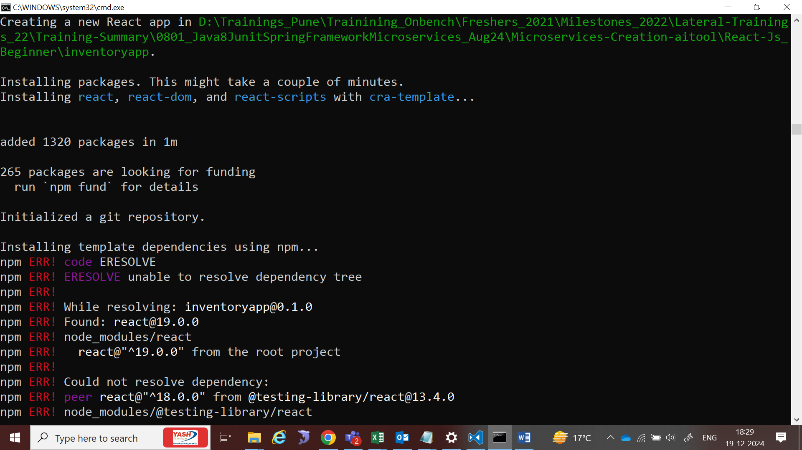

cd inventoryapp

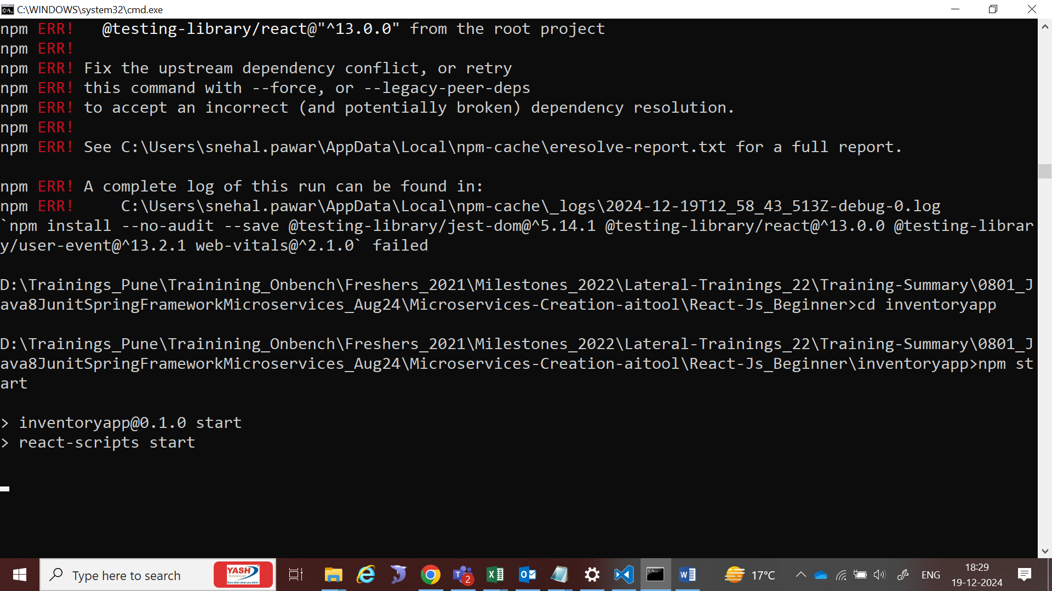

npm start -when you run the app it will give you following error

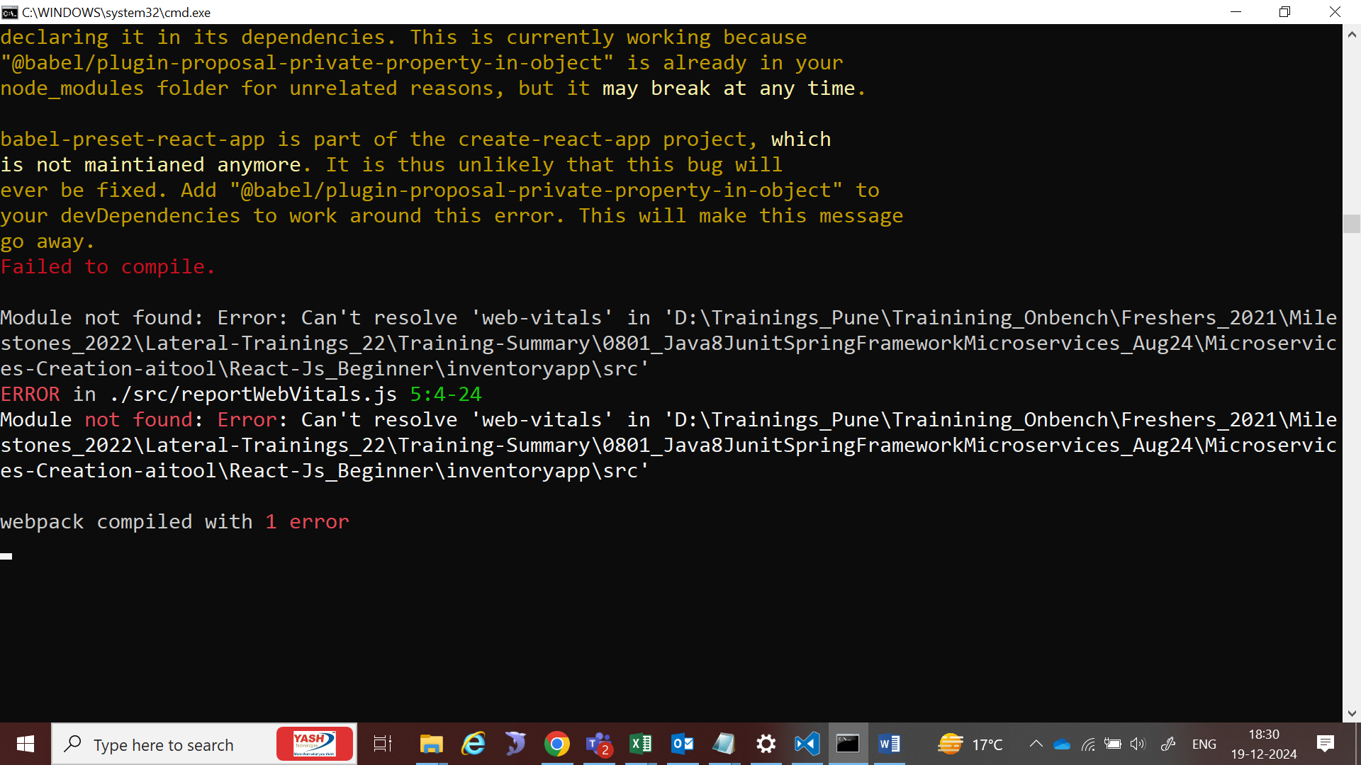

**Web Vitals** are metrics provided by Google to measure and improve the user experience on the web. In React, understanding and using Web Vitals can help developers ensure their applications perform efficiently and provide a seamless user experience.

**Key Web Vitals Metrics**

1. **Largest Contentful Paint (LCP)**:
   * Measures the time taken for the largest visible content (e.g., an image or text block) to appear in the viewport.
   * Goal: **Less than 2.5 seconds**.
2. **First Input Delay (FID)**:
   * Measures the time from when a user interacts with a page (e.g., clicking a button) to when the browser responds.
   * Goal: **Less than 100 milliseconds**.
3. **Cumulative Layout Shift (CLS)**:
   * Measures the visual stability of a page by tracking unexpected layout shifts.
   * Goal: **CLS score less than 0.1**.
4. **First Contentful Paint (FCP)**:
   * Measures the time from when the page starts loading to when any part of the content is rendered.
   * Goal: **As fast as possible**.
5. **Time to Interactive (TTI)**:
   * Measures the time it takes for a page to become fully interactive.
   * Goal: **As fast as possible**.
6. **Total Blocking Time (TBT)**:
   * Measures the time during which the main thread is blocked, preventing user interactions.
   * Goal: **Minimal blocking time**.

**Importance of Web Vitals in React**

1. **Improved User Experience**:
   * React apps are dynamic and interactive; optimizing Web Vitals ensures users experience faster and smoother interactions.
2. **SEO Benefits**:
   * Google considers Web Vitals as ranking factors. A React app with optimized Web Vitals can rank higher in search engine results.
3. **Conversion Rate Optimization**:
   * Faster and more stable applications lead to lower bounce rates and higher conversion rates.
4. **Debugging Performance Issues**:
   * Web Vitals help identify bottlenecks in React applications, such as slow rendering or large layout shifts.
5. **Monitoring React's Impact on Performance**:
   * React's rendering cycles, re-renders, and asynchronous operations can impact Web Vitals. Measuring these metrics helps developers address issues like excessive re-renders or poor component architecture.

**React-Specific Strategies to Optimize Web Vitals**

1. **Optimize LCP**:
   * **Lazy load images** and other heavy resources.
   * Use **code-splitting** to deliver critical content faster.
   * Use optimized image formats (e.g., WebP).
2. **Minimize FID**:
   * Use **React.memo** and **useCallback** to prevent unnecessary re-renders.
   * Avoid long JavaScript tasks that block the main thread.
3. **Reduce CLS**:
   * Specify width and height for images and videos to prevent layout shifts.
   * Avoid inserting dynamic content above existing content.
4. **Improve TTI**:
   * Defer non-essential scripts using React's **lazy** and **Suspense**.
   * Use **React Profiler** to identify slow components.
5. **Minimize TBT**:
   * Split large JavaScript bundles with tools like Webpack or Vite.
   * Reduce the complexity of initial rendering logic.

After explanation

npm install –save web-vitals –dev

npm start

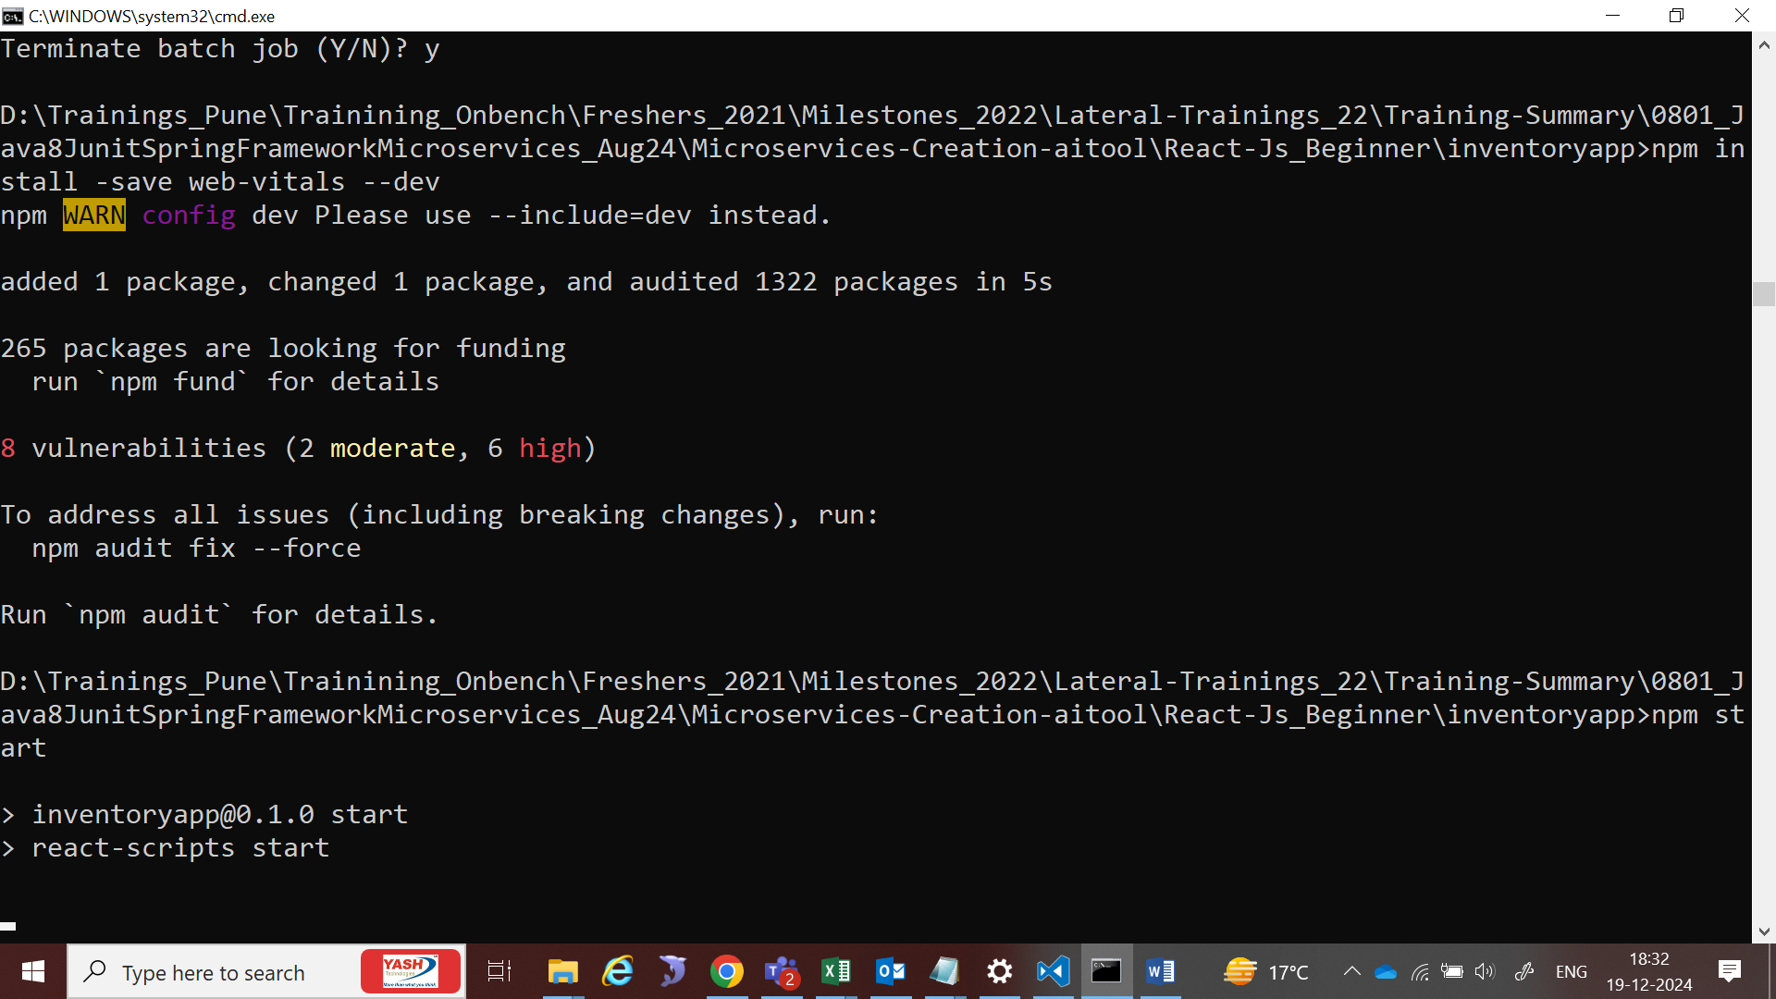 If you're encountering a **Web Vitals error** while bootstrapping a React app, it is typically related to the reportWebVitals function that React includes by default in its newer versions. Here's an explanation of the error and how to resolve it:

**Why Does the Error Occur?**

1. **File Missing or Misconfigured**:
   * The reportWebVitals.js file might be missing or improperly configured.
   * React apps generated using create-react-app include this file to measure performance metrics, but manual edits or deletion of this file can lead to errors.
2. **Incorrect Import or Usage**:
   * The reportWebVitals function might not be correctly imported or invoked in index.js.
3. **Web Vitals Library Issues**:
   * The web-vitals library might not be installed or is outdated.
4. **Unused or Unconfigured Web Vitals**:
   * If you're not using Web Vitals but have its references in index.js, React will attempt to execute the function, leading to errors.

**Common Error Scenarios**

1. **Error: Cannot find module './reportWebVitals'**
   * This happens when the reportWebVitals.js file is missing.
2. **Error: web-vitals is not a function**
   * This occurs if the web-vitals package is not installed or incorrectly imported.
3. **TypeError: reportWebVitals is not a function**
   * This happens if the reportWebVitals function is not exported or imported correctly.

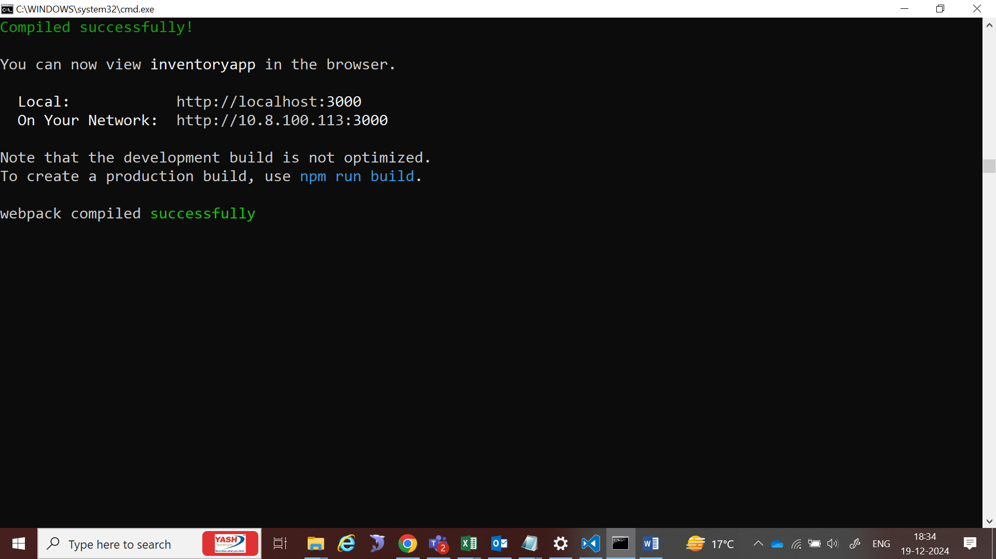

Go to visual studio code and explain about JSX in App component

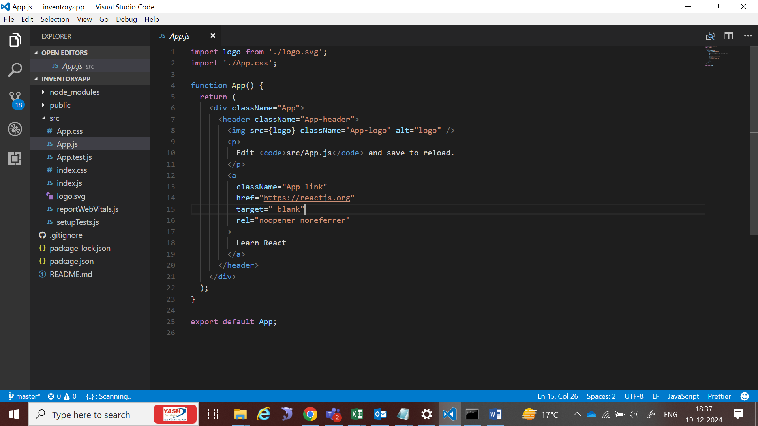

### ****Writing JSX in React****

**JSX (JavaScript XML)** is a syntax extension for JavaScript, used in React to describe the UI structure in a syntax similar to HTML. JSX makes it easier to visualize the structure of the React component and work with it.

#### **Example of JSX:**

jsx

Copy code

import React from 'react';

const App = () => {

return (

<div className="app-container">

<h1>Welcome to React!</h1>

<p>This is an example of JSX.</p>

</div>

);

};

export default App;

#### **Key Features of JSX:**

1. **HTML-like Syntax**: Looks like HTML but is written in JavaScript.
2. **Embedding Expressions**: JavaScript expressions can be embedded using {}.

jsx

Copy code

const name = "John";

<h1>Hello, {name}!</h1>

1. **Attributes**: Attributes in JSX are similar to HTML, but some are camelCase (className instead of class).
2. **Self-Closing Tags**: Like in XML, tags without children must self-close.

jsx

Copy code

<img src="image.png" alt="Image" />

### ****Difference Between JSX and**** React.createElement

Before JSX, React components were defined using the React.createElement method, which is the underlying function that JSX compiles to.

#### **Example of Using** React.createElement**:**

javascript

Copy code

import React from 'react';

const App = () => {

return React.createElement(

'div',

{ className: 'app-container' },

React.createElement('h1', null, 'Welcome to React!'),

React.createElement('p', null, 'This is an example without JSX.')

);

};

export default App;

#### **Comparison:**

| **Feature** | **JSX** | **React.createElement** |
| --- | --- | --- |
| **Syntax** | Looks like HTML/JSX | Pure JavaScript with nested function calls |
| **Readability** | Easy to read and write | Verbose and harder to read |
| **Declarative Nature** | Intuitive, declarative structure | Procedural, less intuitive |
| **Ease of Debugging** | Errors are easier to trace in JSX | Errors are harder to trace due to complexity |
| **Compilation** | Transpiled to React.createElement | No transpilation needed; directly uses function |

### ****How JSX Compiles to**** React.createElement

The JSX:

jsx

Copy code

<div className="app-container">

<h1>Hello, World!</h1>

</div>

Compiles to:

javascript

Copy code

React.createElement(

'div',

{ className: 'app-container' },

React.createElement('h1', null, 'Hello, World!')

);

This compilation is handled automatically by tools like Babel.

n React, **props** and **state** are two fundamental concepts used for managing data in components. While they may seem similar because both hold data, they have distinct purposes and functionalities.

**Key Differences Between Props and State**

| **Feature** | **Props** | **State** |
| --- | --- | --- |
| **Definition** | Props (short for "properties") are used to pass data from a parent component to a child component. | State is a local data store managed within a component, used to handle dynamic data that changes over time. |
| **Mutability** | Immutable (read-only). Cannot be changed by the receiving component. | Mutable. Can be changed within the component using the setState (class components) or useState (functional components) method. |
| **Usage** | Used to configure child components or provide input to them. | Used to manage data that changes within the component. |
| **Scope** | Passed from parent to child, making them external to the component. | Local to the component and cannot be accessed or modified by other components directly. |
| **Responsibility** | The parent component controls the props. | The component itself manages the state. |
| **Examples** | Titles, labels, or any static information passed to child components. | UI interactivity, such as toggling a dropdown or updating input values. |
| **Updates** | Props do not trigger a re-render when changed directly by a parent component (unless the parent re-renders). | State changes always trigger a re-render of the component. |

**Example of Props**

Here’s how props are passed and used:

**Parent Component:**

jsx

Copy code

import React from "react";

import Greeting from "./Greeting";

const App = () => {

return <Greeting name="John" />;

};

export default App;

**Child Component (Greeting.js):**

jsx

Copy code

import React from "react";

const Greeting = (props) => {

return <h1>Hello, {props.name}!</h1>;

};

export default Greeting;

In this example:

* name="John" is passed as a **prop** to the Greeting component.
* Greeting uses the props.name to render "Hello, John!".

**Example of State**

Here’s how state is used within a component:

**Component with State:**

jsx

Copy code

import React, { useState } from "react";

const Counter = () => {

const [count, setCount] = useState(0);

return (

<div>

<h1>Count: {count}</h1>

<button onClick={() => setCount(count + 1)}>Increment</button>

</div>

);

};

export default Counter;

In this example:

* The count value is stored in the **state** using useState.
* Clicking the button updates the state (setCount) and triggers a re-render to display the new count.

**When to Use Props vs State**

| **Use Props** | **Use State** |
| --- | --- |
| When data needs to be passed from a parent to a child | When data needs to change within the component |
| For static or read-only information | For dynamic or interactive information |
| Example: Configuring child components with titles or labels | Example: Managing form inputs or UI toggles |

**Props and State Together**

Props and state often work together. For instance:

* A parent component passes a prop to configure a child.
* The child updates its internal state based on events or interactions.

**Example:**

jsx

Copy code

const App = () => {

const initialValue = 5;

return <Counter start={initialValue} />;

};

const Counter = ({ start }) => {

const [count, setCount] = useState(start);

return (

<div>

<h1>Count: {count}</h1>

<button onClick={() => setCount(count + 1)}>Increment</button>

</div>

);

};

In this example:

* The start value is passed as a **prop** from App to Counter.
* The Counter component manages the dynamic **state** of count.